Teaching Database

Manual – User Friendly Guide

Version 1.0

*This Documentation is for the purposes of assessment requirements for the University of the Sunshine Coast*

|  |  |  |
| --- | --- | --- |
| Teaching Database Documentation – Manual – User Friendly Guide | | |
| The purpose of this documentation is to provide the user or service maintenance operator with a general guide for the Teaching Database. **Note - *This is NOT a Technical Manual\*** | | |
| Amendments | Version Control | |
|  | Version 1.0 | 19 AUG 21 |
|  |  |  |
|  |  |  |
|  |  |  |
|  |  |  |

**Preface**

**Teaching Database**

Teaching Database © is a Management Database to simplify managing the tracking and approval of teaching staff by Administration Managers. This Database is designed to be interactive, therefore, teaching staff can access corporate data, including Service IT providers for updates and maintenance requirements.

This database lists user’s Personal details, Qualifications, Relevant teaching experience, other employment experience, list of publications. Approval to teach and relevant documentation or additional notes with time date stamp included.

This Document sights and regulates using the Privacy ACT (1988) for privacy protection of the Teaching Database. Any attempt to replicate without permission is subject to the Copyright ACT (1968).

|  |  |
| --- | --- |
| **Interface** | **Description** |
| **Home Page** | A user-friendly graphical user interface that shows the user in the application, to login by using the teaching staff portal or admin portal. Dependent on access level. |
| **Teaching Staff Portal** | User login access for Teaching Staff, using a basic user level access, to view, edit or create limited data within the Database. Username and Password required, application is user-friendly and easy to navigate or use search or help function if required. |
| **Admin Portal** | User login for administration access, full access rights to view, edit and create data within the Database. Username and Password required, application is user-friendly and easy to navigate or use search or help function if required. |

**Overview**

This is a basic model of the current components which resides in the Teaching database, an overview of which to guide and understand how the teaching database user interface, database and access level control interacts.

Home Page

Teach Database

Collection

Teaching Staff Portal

Admin Portal

Interface

Access Control

Security Login

Firewall

SSO Login

Contents

Section One 6

Purpose 6

Navigation 8

Accessing Website 8

Figure 1 – Home Page 8

Login Portals 9

Figure 2 – Login Portal 9

User Access 10

Figure 3 – User level access 10

New User Access - Registration 11

Figure 4 – New User registration 11

Existing User Access 12

Figure 5 – Existing User level access 12

Section Two 13

Privilege User Access Portal 14

Figure 6 – Admin Portal access page 14

Privilege User Login 14

Figure 7 – Admin Portal access login 14

User Registration Information – Staff Application form 15

Figure 8 – Staff Application Form 15

SQL Database 16

Figure 8 – SQL Script tables 16

Figure 9 – SQL Script insert commands 17

SQL – alter commands 18

Trouble Shooting 19

Installation 20

Prerequisites 20

Installation Steps 20

# Section One

# Purpose

The purpose of this User-guide is to assist a user utilizing the Manual Documentation in navigating, accessing, and providing an overview of how the Teaching Database functions. Also, in problem solving an error which may occur and Helpdesk support contact information if required.

This user-guide is for a generic level user and a privilege and service administration user level. The documentation Part 2 section is restricted to privilege and service administration users only.

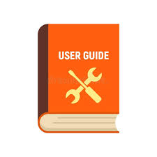

# Navigation

## Accessing Website

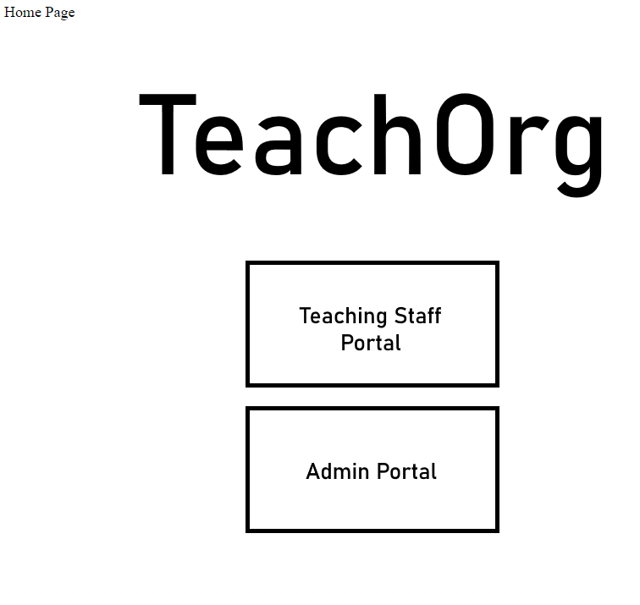

### Figure 1 – Home Page

The current Hope Page in HTML format is the user interface to access required user access to perform functions within current job position. As per Network Access Form, any unauthorized attempt to access a level not cleared to, will result in disciplinary action by regulations, policy in force. Users are to read the User policy before accessing the home page.

## Login Portals

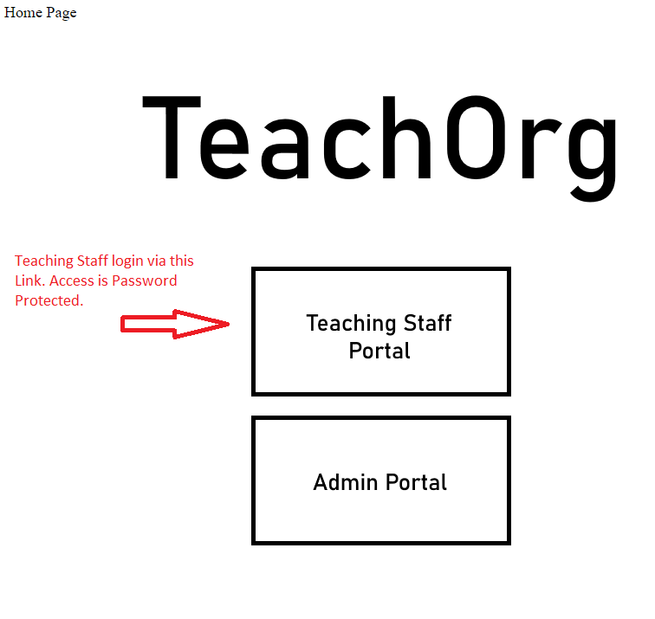

### Figure 2 – Login Portal

The login user Portal is currently displayed for generic user level access, to perform functions of their duty as Teaching staff. Selecting the Teaching Staff Portal will link to a login page which is password protected.

## User Access

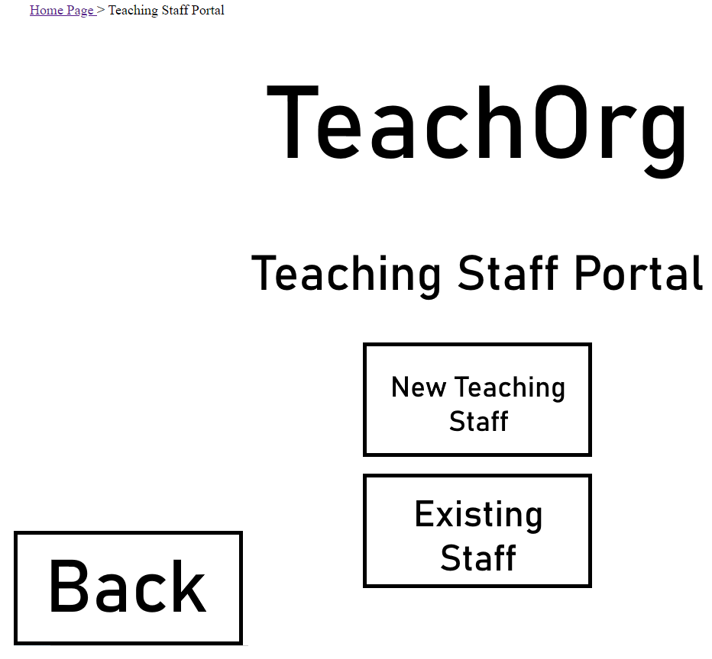

### Figure 3 – User level access

Selecting Login Portal of generic user in Figure 2 will load webpage as per Figure 3, users either currently have an existing login or require registering for a new login access for new staff. New staff requiring access will require to register for a New User access Figure 4 .

## New User Access - Registration

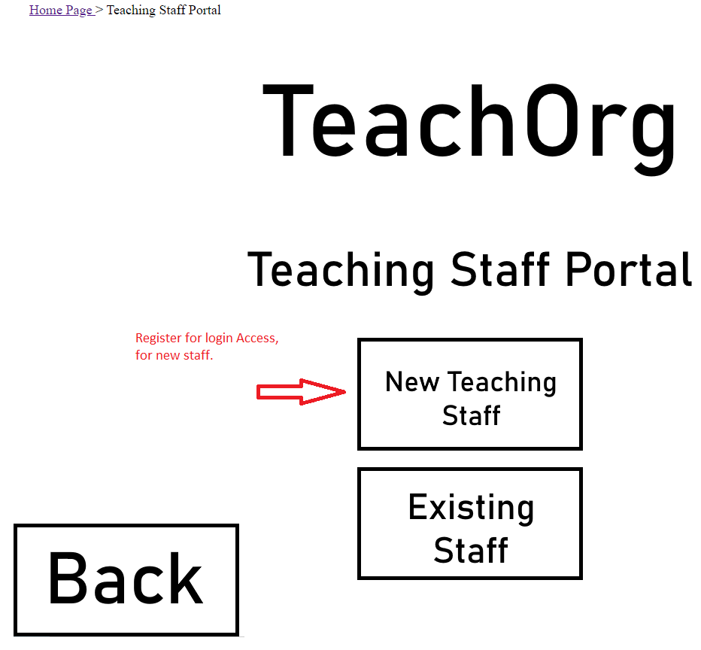

### Figure 4 – New User registration

New users are to select the New Teaching Staff button as per Figure 4 and input information as required for approval to access the teaching database through new user registration.

## Existing User Access

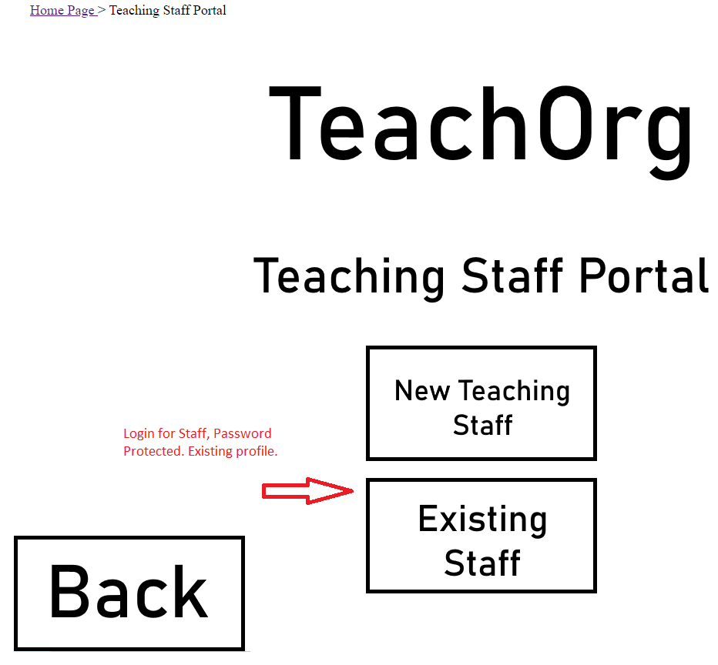

### Figure 5 – Existing User level access

Users with existing login

# Section Two

**Note: Stop print from Section One before this page. Print only from this page onwards for privilege access users. Cut from this page onwards if require a digital copy.**

Privilege user and Service administration user access only to view Section two of the Manual Documentation.

This Section provides further in-depth details of the Teaching Database, the front end, back end, database functions and critical coding for the performance of this functioning database.



WARNING

!!!DO NOT PROCEED IF YOU DO NOT HAVE ACCESS PRIVILEGES!!!

## Privilege User Access Portal

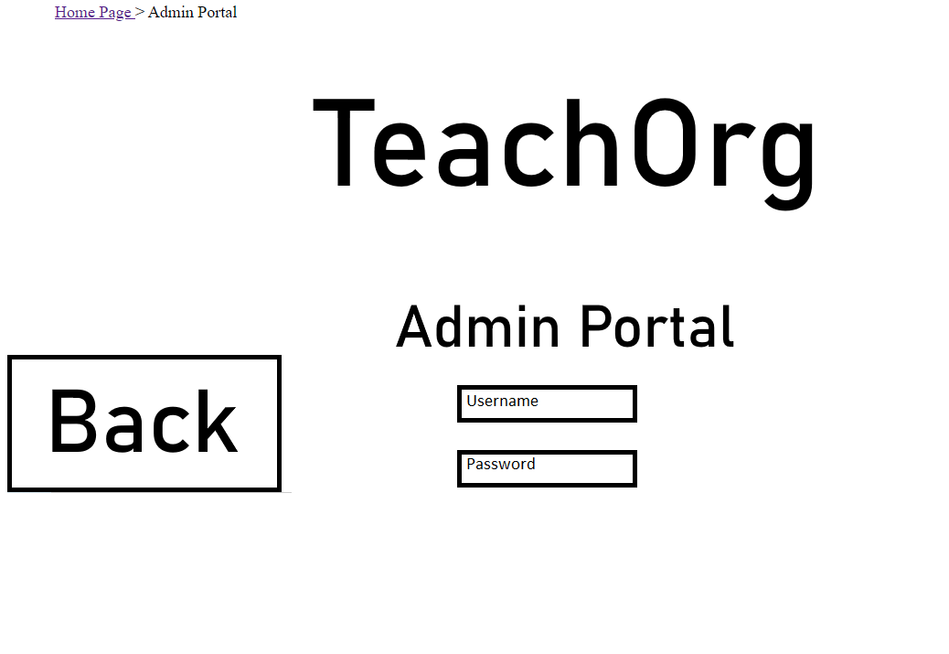

### Figure 6 – Admin Portal access page

Selecting the existing staff button Figure 5 will load the Admin Portal page as per Figure 6, access is password protected.

## Privilege User Login

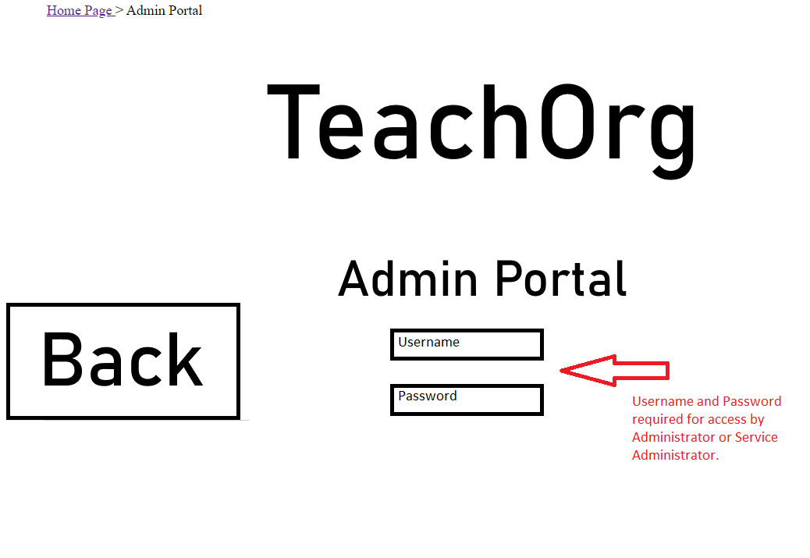

### Figure 7 – Admin Portal access login

Privilege user must enter a valid username and password as display in Figure 7. Access will be granted for user to create, amend, or delete information that will be updated in the database.

## User Registration Information – Staff Application form

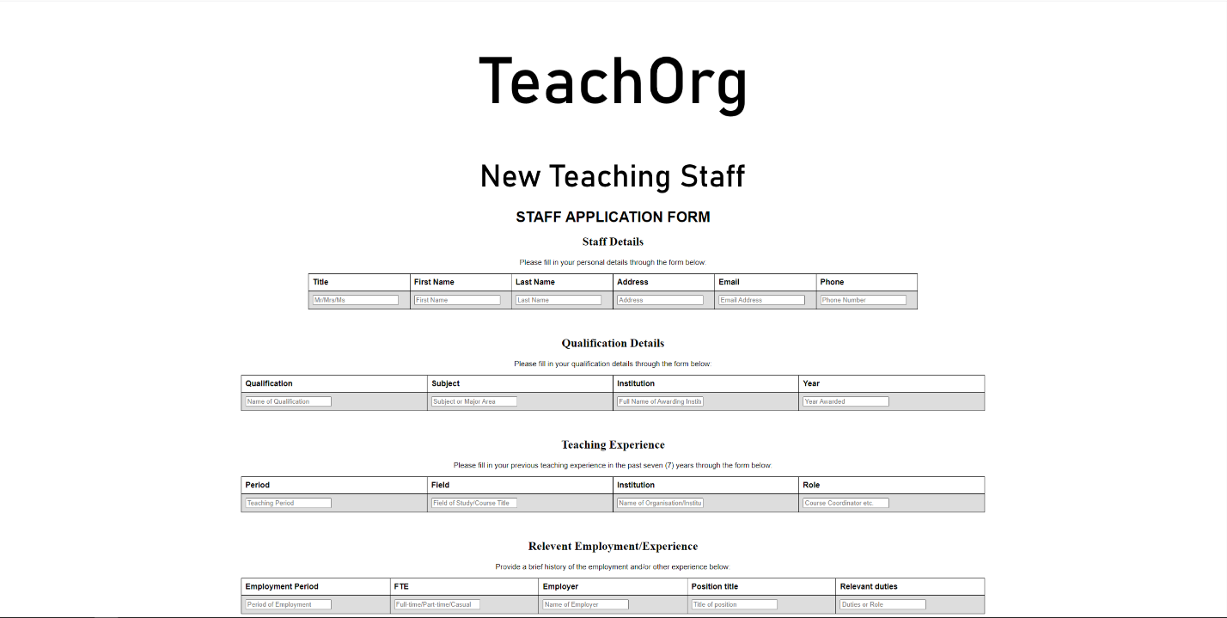

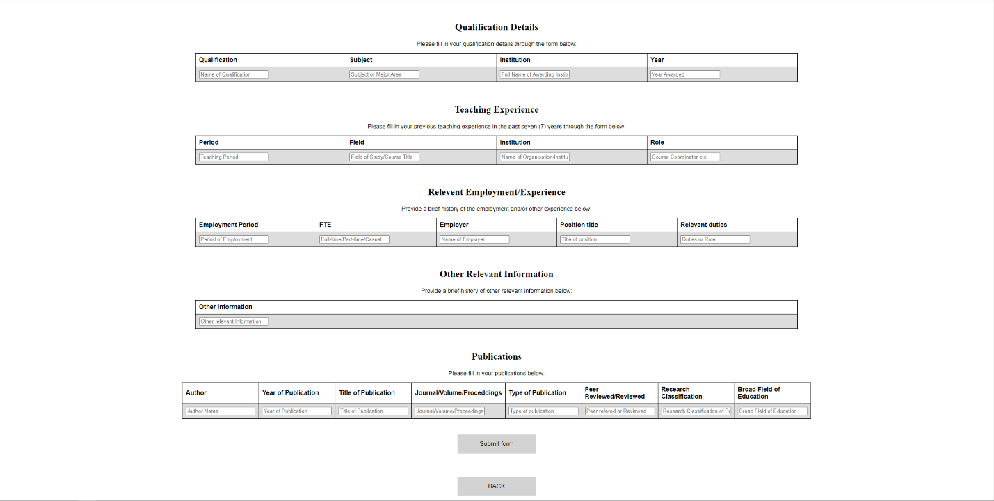

### Figure 8 – Staff Application Form

Staff application form is self-explanatory, information data input in each field will be updated in SQL database, where the data resides. Submit button will execute this function for a new Teaching Staff (user)

# SQL Database

The Teaching Database is currently utilising SQL workbench and has two SQL query scripts with pertinent information stored, any requirements to alter any column or table is to be performed at this location. Note: changes must also be made in HTML files to reflect the changes made in SQL database.

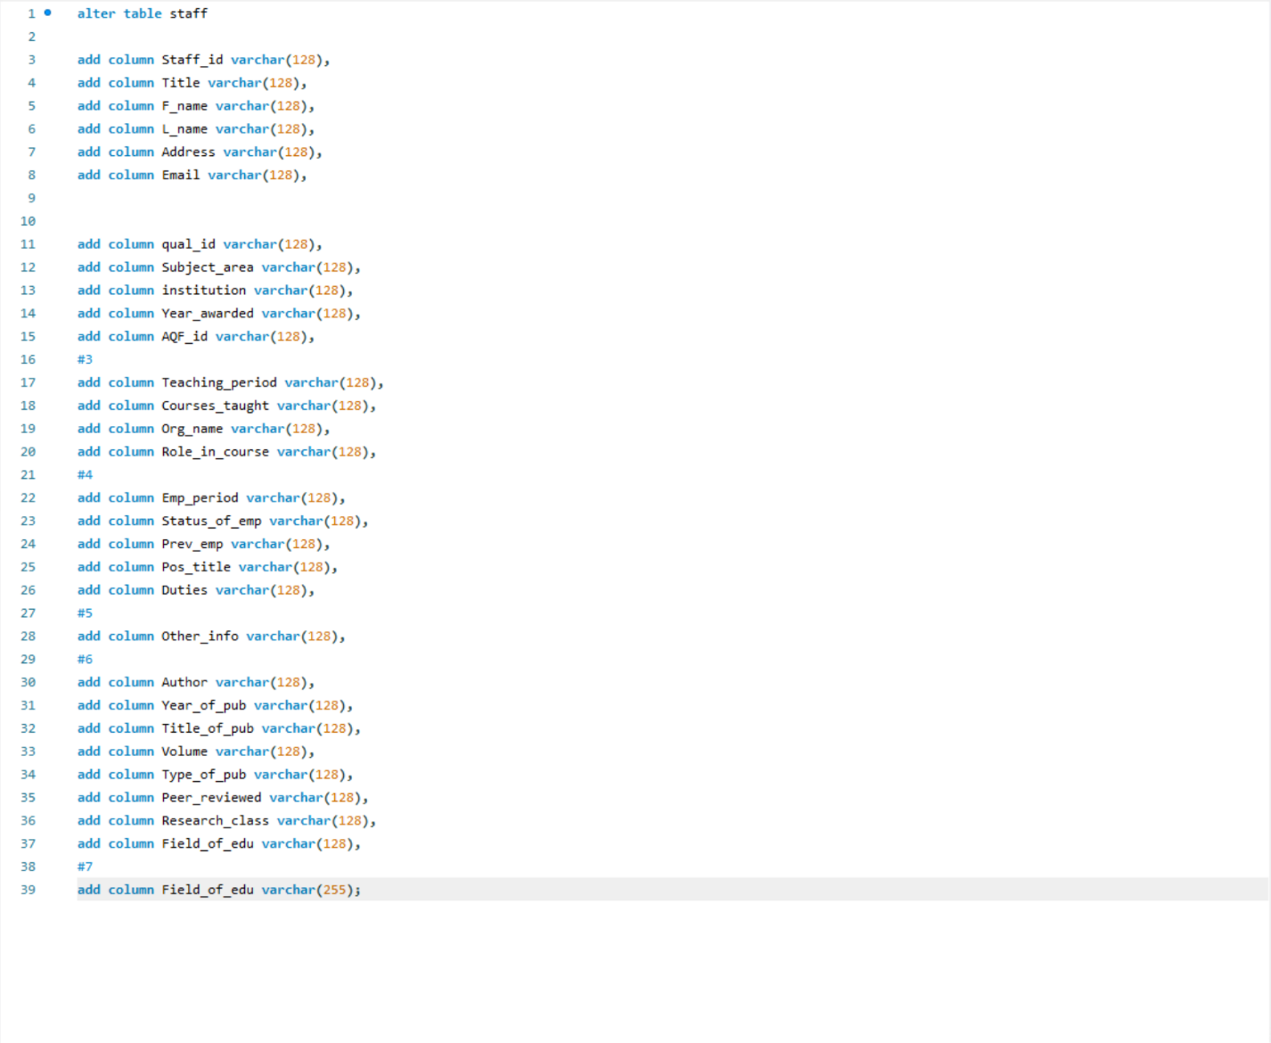

### Figure 8 – SQL Script tables

An understanding of SQL coding is required before access SQL queries utilising SQL Application (SQL Workbench etc.). Also accessing Python and HTML files to alter commands to reflect changes if tables or structure is amended.

Inputs for SQL database can be manually input as per Figure 9, insert information or values as displayed below.

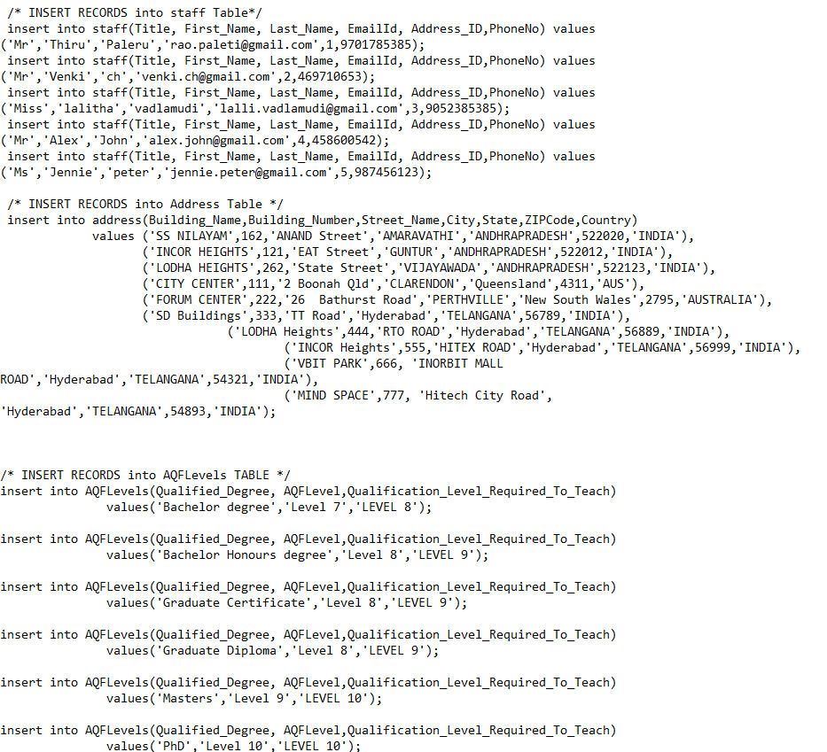

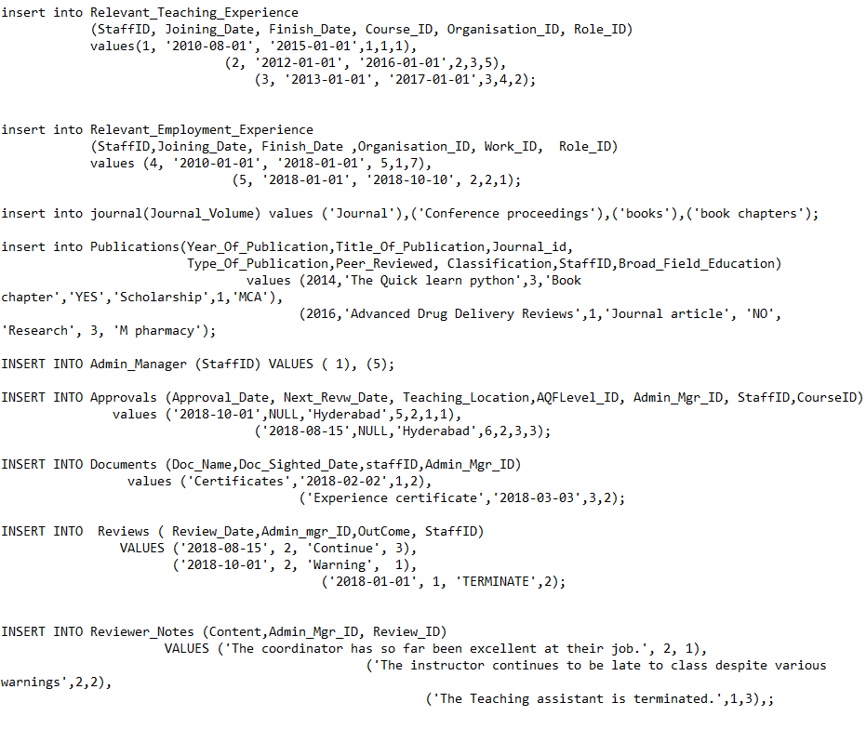

### Figure 9 – SQL Script insert commands

SQL alter commands are for a higher level of coding to make changes for the Teaching database, and updates required or changes that may occur, will require an alter command to reflect the changes. This must also be inserted in the control version at the beginning of the manual.

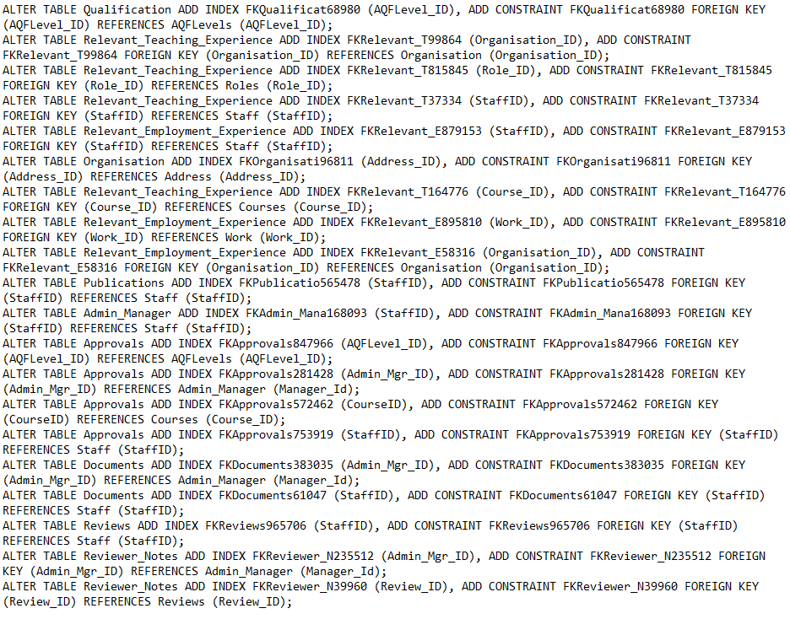

### SQL – alter commands

# Trouble Shooting

In the instance of any errors occurring, reload page. If problem persists, restart application. If the problem is still occurring, restart device.

Only make changes if required and understand Web development and SQL coding.

Under no circumstances are inappropriate lines of text or images are to be used in this documentation, as per policy, disciplinary action may follow.



# Installation

*Please note the installation of this software requires **extensive knowledge** around computing, more specifically Linux / Ubuntu*

This software is only compatible with the Linux operating system. This will NOT work on a Windows operating system or any other for that matter. The software itself is accessible to use through any web-browser regardless of the operating system.

## Prerequisites

The Linux based system must have Python3 installed alongside the Python Bottle.py framework embedded into the system. If you are to come across any errors regarding dependencies, check the terminal log and install any required files it outputs.

## Installation Steps

Step 1. Download the .zip file containing the following components:

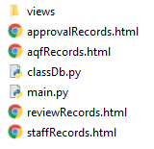

Inside the “views” directory you will find the following:

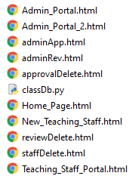

Please refrain from renaming any of the files as doing so will result in the system not functioning.

Step 2. Place all the files as they are into your desired location on a system running Linux.

Step 3. Running “Main.py” is the webservice file and starts the system. You may need to adjust the IP address and port located at the very bottom of the file.